Ranque-Hilsch Vortex Tube
I wanted to build this tube really fast so I kept the design as simple as possible. Surprisingly with this tube I got the best results so far! With an air inlet temperature of 23.4°C (74°F) and about 551kPa (80 psi) of air pressure the best hot end temperature of the tube was 44.8°C (112°F) and the best cold end was -13°C (8.6°F). That is a whopping 57.8°C difference between the hot and cold ends and the cold end was below freezing. An early Christmas miracle maybe?.. read on to find out! Unfortunately I couldn't measure the airflow during the experiment but what I do know is my home garage compressor was not able to get these results because it couldn't keep up the air pressure at the flow rate required by this tube. To get anything to happen I had to take this vortex cooling tube into my work and run it on a industrial sized compressor.

Here is an overview diagram of the components used in this tube. It only took me about an hour to build it and as always was made from crap I have lying around my garage (and living room, kitchen etc...). You should be able to click on the picture for a better view.

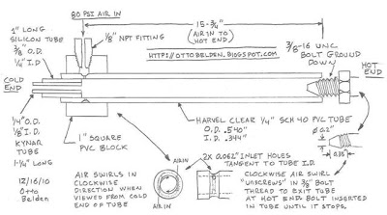
Homemade Ranque-Hilsch Vortex Cooling Tube Construction

Below is a summary of the critical dimensions and performance of this Vortex Tube:
Tube I.D: 8.17mm 0.340"
Cold Plate Orifice: 6.35mm 0.250"
2 Inlet Jets each: 1.57mm 0.062"
Length: 400mm 15.75"
Inlet Air Pressure: 551kPa 80psi
Inlet Air Temp: 23.4°C 74°F
Outlet Hot Temp: 44.8°C 112°F
Outlet Cold Temp: -13°C 8.6°F

This Vortex Tube used a 1/4" schedule 40 pipe made of PVC that has an I.D. of 0.344". and an O.D. of 0.540". This pipe is considered to be 1/4" even though there is no 1/4" dimension in it and it's made by a company called Harvel, HERE is a link to their site. There is a lot of evidence in the literature that the pipe that you use should be thermally non-conductive or if it is a good conductor (like metal) it should be insulated. I decided to use PVC because I had it laying around and of the three vortex tubes that I have made the metal one didn't work too good. Metal might be the reason for the poor performance.

I have read that having more than one inlet jet tends to work better than one so I decided to drill two of them. (The last metal tube that didn't work had one inlet). To get the air into both of the jets I filed a groove around the outside of the 1/4" plastic tube to make a manifold. I chose 0.062 inches for the jets diameter because that was the drill that was left over in the chuck from the last project.

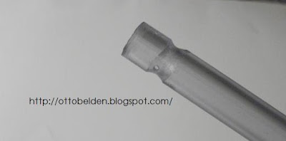
Vortex Tube inlet 'manifold groove' and inlet jet hole

In the above picture you can see the groovy manifold and one of the inlet jet holes. There is another inlet jet hole on the other side of the tube. The groove allows air to flow around the tube and enter the jet holes when this end is later inserted in a block. Have a look again at the above construction diagram and read on if this isn't clear yet.

To get the air swirling around the inside of the tube (and not just blowing into the center of the tube) the jet holes had to be drilled tangent to the inside wall. I decided to drill them in a manner that would cause the vortex to swirl around in a clockwise direction when viewed from the cold end of the tube. I did that because I used a 3/8" bolt as the 'Cone Valve' and it has a right hand thread. This way the hot air swirling around against the inner wall of the tube can easily 'unscrew' out the bolt thread.

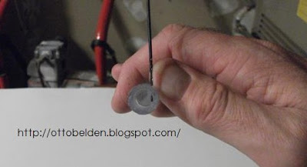
One inlet jet hole drilled tangent to the I.D. of the vortex tube

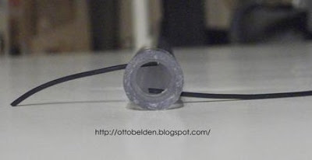
Two inlet jet holes with wire inserted to show relationship / direction

As you can see from the above pictures I drilled two holes and they are on opposite sides of the tube. These are both drilled in the manifold groove so air can get into them and they are at a very slight angle toward the hot end of the tube. The angle is to help get the air moving away from the cold end. In the literature about 5° of angle is optimum but I just eyeballed it because being that precise with a small drill in a plastic tube isn't easy.

After getting the holes drilled in the tube I drilled a 0.54" hole in a 1 inch square block of PVC. This hole is sized so the tube in the above picture will slide in snugly. I then drilled and tapped a 1/8-NPT hole in the 1" block at 90° to the first hole for a pipe fitting. Check out the picture below!

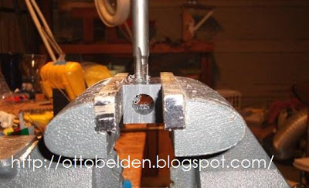
Tapping a 1/8-NPT hole at a right angle to the 0.54" hole

In the above picture you are looking right down the 0.54" hole that the 1/4" PVC tube will be shoved into and glued. When I put the tube into this hole I centered the manifold groove right under the 1/8-NPT hole. That way when the air enters through the pipe fitting it can pass through the space formed by the groove and get to the inlet jets. I oriented the jets to be 90° to the inlet pipe fitting to help get an even flow in each jet, so in the above picture the jets would be horizontal.

After gluing the 1/4" tube into the 1" PVC block I installed a pipe fitting and a thermocouple to measure the inlet air temperature. The last step was to grind down the 3/8" bolt to make the cone valve.

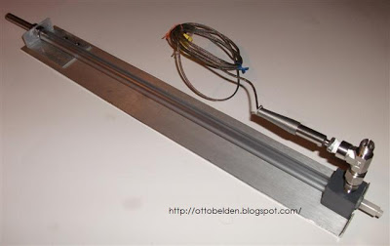
My homemade Vortex Cooling Tube

Here is a picture of the finished tube. You can see the air inlet area in the lower right of the picture with the 1" square PVC block and air fittings. / thermocouple. Sticking out the cold end of the tube in the lower right is two pieces of white colored tube. Those white tubes make up the Cold Plate and are nothing more than a 1"4 I.D. piece of Kynar tubing inserted into a 3/8" O.D. silicon tube then both pushed into the PVC tube. Confusing isn't it? Refer way back to the construction diagram near the top of this post and it will make more sense. Also watch the exciting video at the end of this post!!

The last step I mentioned above was to grind down the 3/8" bolt to make the cone valve. I did this by cutting the head off the bolt and chucking it in my drill press with the threads sticking out. Once I got it spinning in the drill press I held a file against it and shaped it into a bullet shaped point that is about 0.2" on the end.

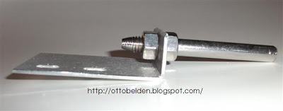
Vortex tube Cone Valve made from a 3/8" bolt

As you can see I mounted the bolt on a bent piece of aluminum plate to support it. I did this because I wanted to be able to adjust the bolt in and out of the tube. The adjustment was intended to vary the amount of hot air that was coming out to control the temperature. This did allow me to adjust the temperature and I found that the hottest (and coldest) temperature was with the bolt shoved all the way in the tube. Initially I had a small piece of the 1" PVC block with a hole in it to support the PVC tube while the bolt was being adjusted but I got interesting results with that set up. Check out the picture below:

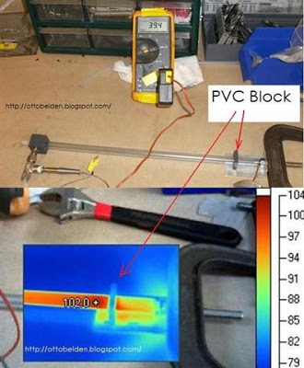
Thermal image of my Vortex tube with the 1" block support

Pretty neat picture isn't it? It appears that the little piece of PVC support at the end of the tube is acting like a heat sink and drawing away some of the energy. I expect that if I let the tube run awhile the PVC support will reach equilibrium with the tube temperature but even then it's dissipating some of the heat. This is why a plastic tube works better than a metal one and insulating a plastic tube will probably work even better.

After that first run I decided that I didn't need to adjust the bolt in and out and therefore didn't need the plastic support. I mounted the entire tube to a aluminum plate with the bolt inserted into the tube acting as the support for the tube. With that setup I got the best results.

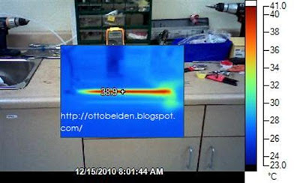
Thermal image of the Vortex tube without support

Below is a video of the construction and testing of my Ranque-Hilsch Vortex Cooling Tube. If there is anything about this experiment that isn't clear please leave a comment on the blog or send me an email at ottobelden@yahoo.com and I'll be happy to help. Just like the other tubes I built this one was a lot of fun to make but even more fun because it worked so well!

